MODERN MOTORS SERVICE AND PAYROLL MANAGEMENT SYSTEM

ABSTRACT:
This Web application provides payroll processing for the employees in which the client can update employee details, salary, Timesheet and attendance . It also provides service at the doorstep for customers after the customer book’s their required service and they are ready to checkout. The customer receives a confirmation email of their service or products after their required purchase. In this website we are selling products of car accessories such ah windshields, mirrors, indicators, lubricants…etc. Each product has their own specific requirements. If the customer wants to cancel the items, the items which they have purchased ,they can cancel their order and cancellation mail is send to the customers to their respective Mail-Id.

INTRODUCTION:
Modern motors is a mechanical shop in which they provides services and sell products . A web application is mainly used for submitting and retrieving the data from the database. This application provides payroll processing for the customers by collecting the details of the employees and storing it. The employee salary and their attendance sheet is maintained. This application provides services for the customers in their requested date and time. This application also sells products in car accessories such as universal parts. The benefits of the application is that the client can easily maintain employee data and can keep a track of the products and their resources. Therefore if the customer needs any services he/she does not need to go to the shop to take the service, they can comfortably add their required package of service in which they need with the knowledge of their interested date and time. The employees in the shop will provide services to the customers in their place at the particular date and time in which customers have mentioned. If the customer has any queries they can write their complaints in the contact us form in which we have provided in the website and the admin will reach them as soon as possible. The website provide immense amount of services and products which in need satisfy customers and their expectations.

SYSTEM SPECIFICATIONS:
Hardware Requirements:
- RAM minimum 2GB.
- Minimum Pentium-IV (Processor).
- 1MB Cache Memory – Optional
- Hard disk 10 GB
- Internet connection.
Software Requirements
- Front end – HTML, Css, Java script(Notepad++)
- Backend – PHP, MySql.
- Web browse-Google chrome (or) Firefox.
- Operating system-Windows7

SYSTEM ANALYSIS:
Existing system:
In Modern motors if a customer needs a service he/she needs to go to a shop. The customer details is not maintained properly, all details are maintained in a paper sheet. Efficient amount of time is taken to maintain the accuracy of data. The employee details and their salary wages is maintained in a book which is not preserved in an accurate manner.
DEMERITS
- Manual entry
- Time consuming
- Time delay in response
Proposed system:
Provides stock inventory in car accessories such as mirrors, lubricants…etc.
This website also provides payroll processing for the employees.
Provides services for the customer such as:-
- Periodic services
- Denting and painting
- Car spa and cleaning
Builds stronger relationship with the customers.
An email is sent to the customers after purchasing their items.
No time delay in response i.e if the customer wants to know any details of the products or services , they can ask any queries in contact us form.
Cash on delivery is available for the customers after purchasing their products.
If the customer cancel their products ,a cancellation email is send to their perspective mail-id.
ADVANTAGES
- Cost effective and time saving.
- The services are given at the doorstep so the customers no need to go to the shop

CONTEXT ANALYSIS DIAGRAM:
Zero Level DFD:
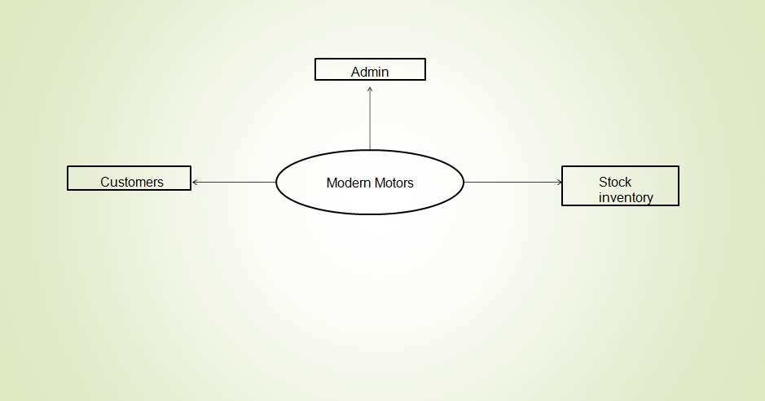
Level 1 DFD:
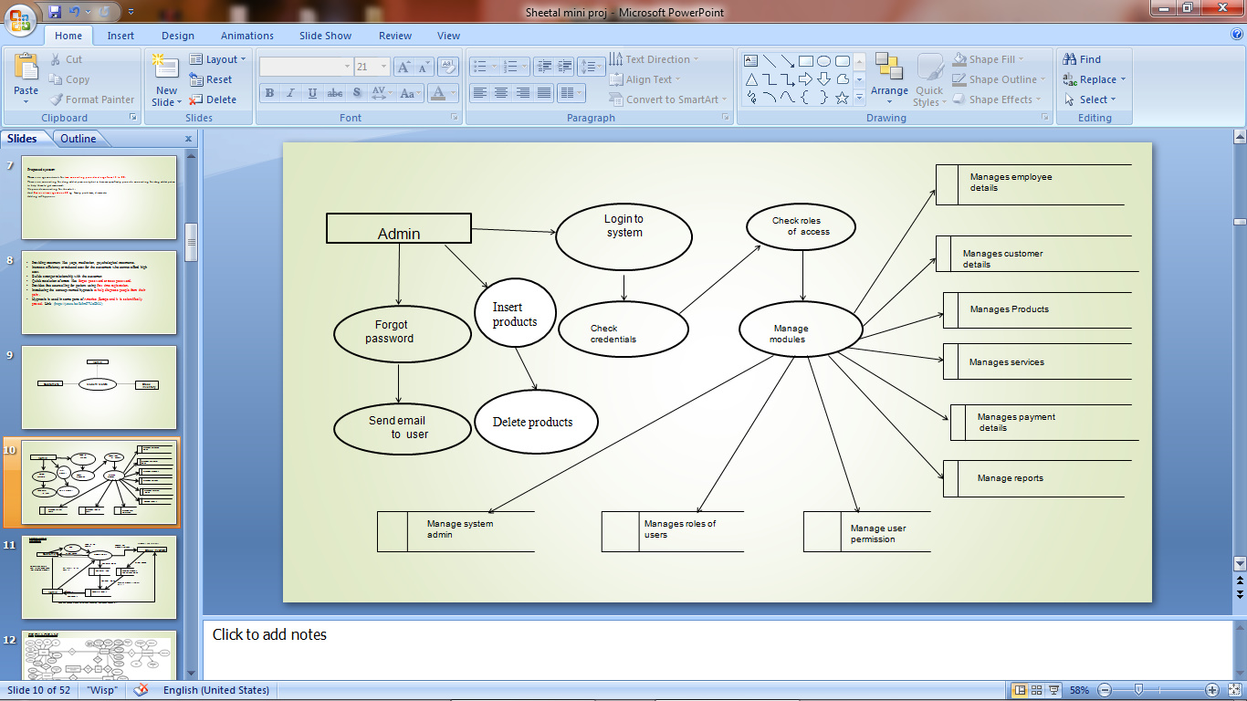

Level 2 DFD:
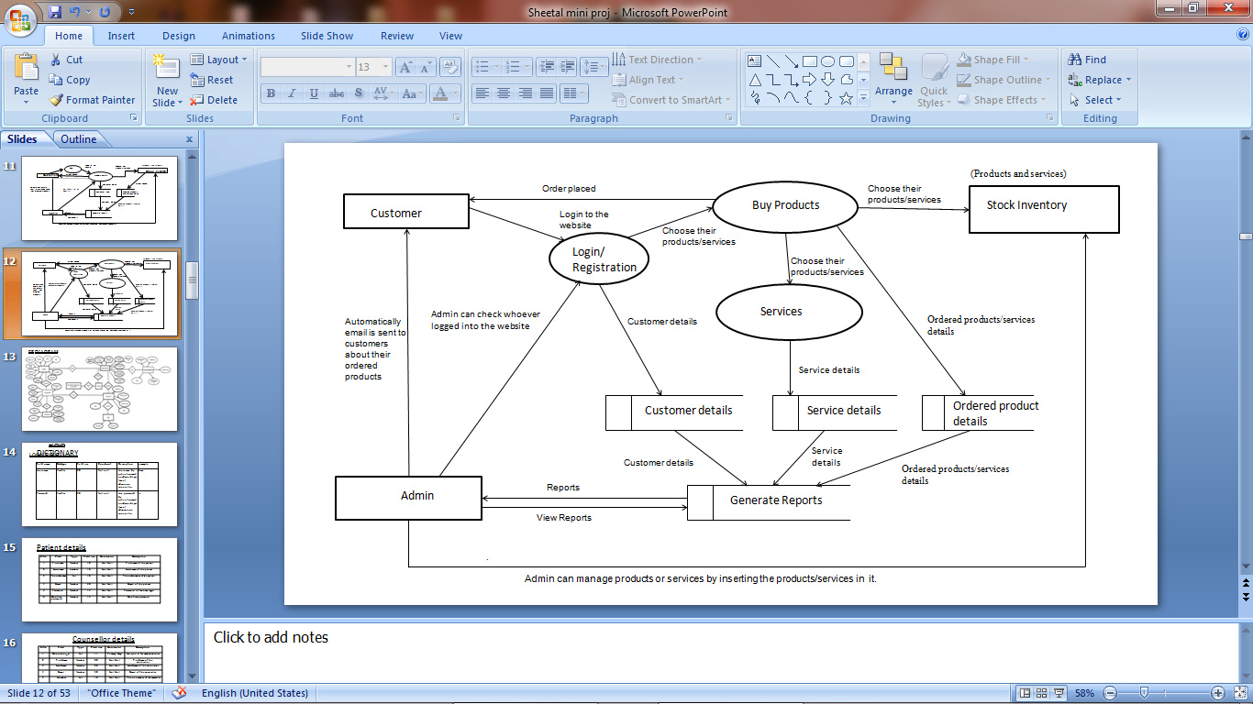

ER DIAGRAM:
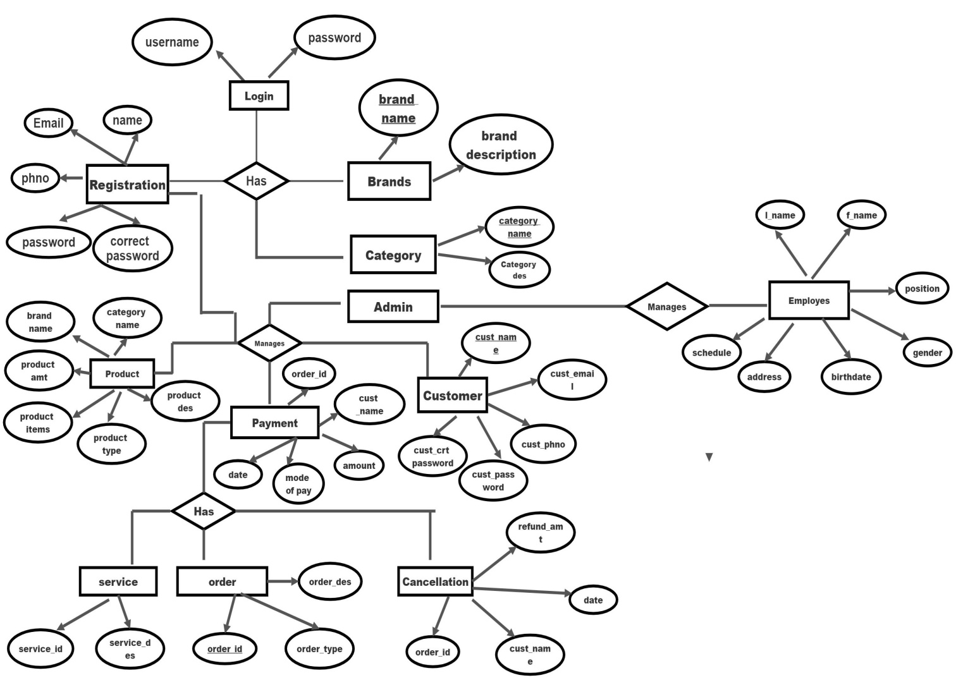

DATA DICTIONARY:
Login table :

Customer details

Field name | Datatype | Field size | Constraint | Description
Username | Varchar | 20 | Not null | Username used by customers
Password | Varchar | 20 | Not null | password used by customers
Field name | Datatype | Field size | Constraint | Description
Cust_name | Varchar | 10 | Primary key | Name of the customer
Cust_email | Varchar | 30 | Not null | Email of the customer
Cust_phno | Varchar | 10 | Not null | Phonenumber of the customer
Cust_pswd | Varchar | 10 | Not null | Password of the customer
Cust_cpswd | Varchar | 10 | Not null | Confirmpassword of the customer

Product details
Field name | Datatype | Field size | Constraint | Description
Category name | Varchar | 20 | Foreign key | Name of the product category
Brand name | Varchar | 20 | Foreign key | Brand name of the product
Product type | Varchar | 20 | Not null | Type of the product
Product amt | Int | 30 | Not null | Amount of the product
Product items | Varchar | 20 | Not null | Items of the product
Product desc | Varchar | 50 | Not null | Description of the product

Brand details
Field name | Datatype | Field size | Constraint | Description
Brand name | varchar | 10 | Primary key | Name of the brand
Brand desc | varchar | 50 | Not null | Description of the brand

Category details
Field name | Datatype | Field size | Constraint | Description
Category name | varchar | 10 | Primary key | Name of the category
Category desc | varchar | 50 | Not null | Description of the  category

Order details
Field name | Datatype | Field size | Constraint | Description
Order_id | Int | 10 | Primary key | Id of the order
Order_type | Varchar | 10 | Not null | Type of order
Order_desc | Varchar | 50 | Not null | Description of the order

Service details
Field name | Datatype | Field size | Constraint | Description
Service_id | Int | 10 | Not null | Id of the service
Service_desc | Varchar | 50 | Not null | Description of the  service

Payment details
Field name | Datatype | Field size | Constraint | Description
Order_id | Int | 10 | Foreign key | The id of the order
Cust_name | Varchar | 10 | Foreign key | Name of the customer
Amount | Int | 20 | Not null | Amount to be payed by the customer
Mode of pay | Varchar | 10 | Not null | Mode of payment
Date | date | 10 | Not null | Date of payment

Cancellation details
Field name | Datatype | Field size | Constraint | Description
Order_id | Int | 10 | Foreign key | The id of the order
Cust_name | Varchar | 10 | Foreign key | Name of the customer
Date | date | 10 | Not null | Date of payment
Refund  Amount | Int | 20 | Not null | Amount to be refunded

Field name | Datatype | Field size | Constraint | Description
F_name | Varchar | 10 | Not null | First name of the employee
L_name | Varchar | 10 | Not null | Last name of the employee
DOB | Date | 10 | Not null | Date of birth
Address | Varchar | 30 | Not null | Present Address of the employee
Gender | Varchar | 10 | Not null | Gender of the employee
Position | Varchar | 10 | Not null | Position mentioned for the employee
Schedule | Varchar | 10 | Not null | Schedule of the employee
Employee details

TABLE RELATIONSHIP:
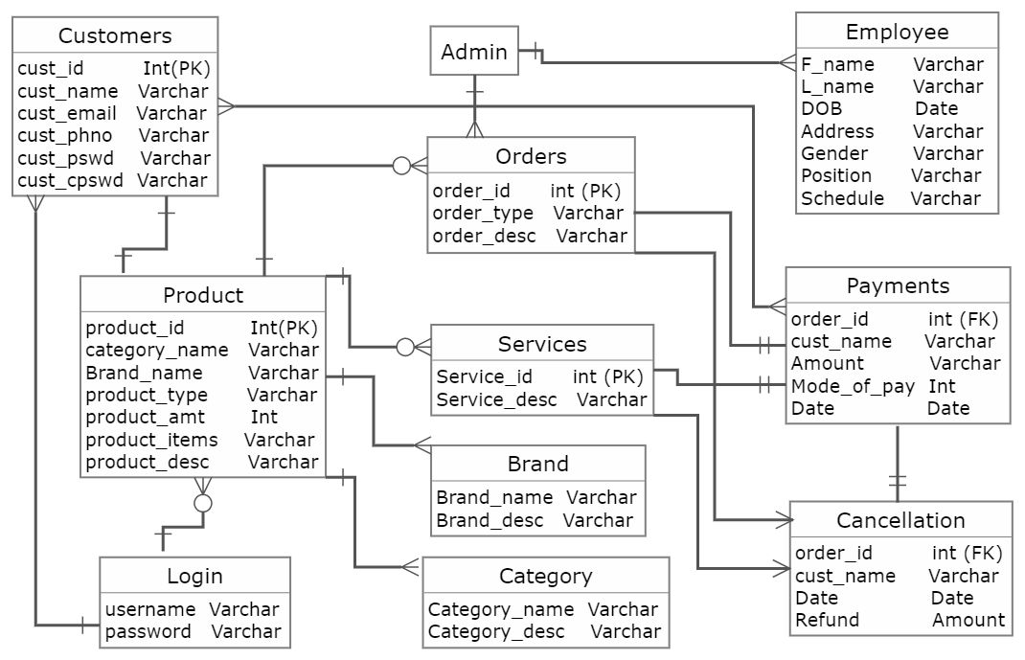

MODULAR DESCRIPTION:
Admin:
The admin can manage login details. The admin manages user permission and the users whoever logged into the system. He also manages employee details and their daily wages. Manages and track notification system. Manages all the other details(Customer details, employee details...etc)
Customer:
A customer needs to give the registration details such as (name, email, phno, pswd, cpswd).After registering they are asked to login to the website. Then they can purchase or order the required items or services.
Products:
A product module has brand name and category name which is used for creating a product category and inserting the products into it. Each product has its own specifications, price and descriptions. After inserting a product which is done through admin panel , it is asked to upload the images of the products. The products will be displayed in the website with the category name and its descriptions.
Category:
A category module contains category name and description. Each category has also a subcategory which is used for inserting the products.
Brand :
A brand module contains brand name and description. Each brand name represents the product brand and their items.
Order Details Module:
After the customer purchase the items their order ID and their order type would be shown in order history. The customer can also track their order with their order ID.

Service Details Module:
After the customer purchase for the required service , their service ID would be shown in order history. The customer will receive service at the date and time they have mentioned.
Payment Module:
The customer will be directed to Razor-pay after they proceed to checkout their order or service.The customer needs to enter their card details, their email and phone-no. Date of payment will be mentioned.
Cancellation:
If the customer needs to cancel the order or service , they can cancel their order/service underneath the placed order/service which will be mentioned. After the customer cancel their order/service they will receive a Cancellation Mail.
Employee Module:
The Employee details will be managed in the admin side. The admin will enter all the employee details. After entering the details employee id will be generated. The employee must enter the employee id in which time they come and in which time they leave. The employee’s salary , deduction, net-pay and gross pay will be calculated. The payroll will be generated after the calculation and then they can take a print of it.

